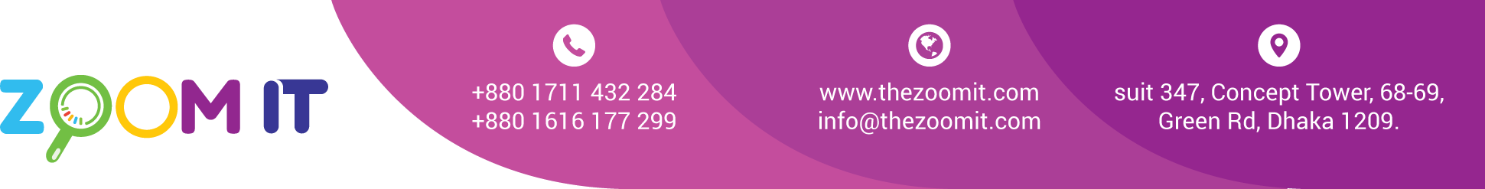

**Bill**

|  |  |
| --- | --- |
| Date | 29/10/2022 |
| INV. NO. | 10131 |

|  |  |
| --- | --- |
| Name | **CODEX Oil International** |
| Address | 241/1-C, Hasan Tower, South Pirerbag, Mirpur, Dhaka-1216. |

|  |  |  |  |
| --- | --- | --- | --- |
| **Sl.**  **No.** | **Description** | **tife** | **Value in Taka** |
| 1 | Software Development | Partial | 20,000 |
|  | | Total | 20,000 |
| Paid |  |
| Due |  |

BANK Details

Ac no: 20501210205489706

Ac Name: SHIBLEE MOZUMDER

Islamic Bank Bangladesh LTD

Comilla branch

Ac Name: ZOOM DIGITAL AC NO: 2228119002279

Prime bank Racecourse Branch

Signature